**DR. SRINIBASH DASH**

**ASSOCIATE PROFESSOR & HEAD**

**SCHOOL OF MANAGEMENT**

**Decision making** is the **process** of **making** choices by identifying a **decision**, gathering information, and assessing alternative resolutions. Using a step-by-step **decision**-**making process** can help you make more deliberate, thoughtful **decisions** by organizing relevant information and defining alternatives

**Step 1: Identify the decision**

You realize that you need to make a decision. Try to clearly define the nature of the decision you must make. This first step is very important.

**Step 2: Gather relevant information**

Collect some pertinent information before you make your decision: what information is needed, the best sources of information, and how to get it. This step involves both internal and external “work.” Some information is internal: you’ll seek it through a process of self-assessment. Other information is external: you’ll find it online, in books, from other people, and from other sources.

**Step 3: Identify the alternatives**

As you collect information, you will probably identify several possible paths of action, or alternatives. You can also use your imagination and additional information to construct new alternatives. In this step, you will list all possible and desirable alternatives.

**Step 4: Weigh the evidence**

Draw on your information and emotions to imagine what it would be like if you carried out each of the alternatives to the end. Evaluate whether the need identified in Step 1 would be met or resolved through the use of each alternative. As you go through this difficult internal process, you’ll begin to favor certain alternatives: those that seem to have a higher potential for reaching your goal. Finally, place the alternatives in a priority order, based upon your own value system.

**Step 5: Choose among alternatives**

Once you have weighed all the evidence, you are ready to select the alternative that seems to be best one for you. You may even choose a combination of alternatives. Your choice in Step 5 may very likely be the same or similar to the alternative you placed at the top of your list at the end of Step 4.

**Step 6: Take action**

You’re now ready to take some positive action by beginning to implement the alternative you chose in Step 5.

**Step 7: Review your decision & its consequences**

In this final step, consider the results of your decision and evaluate whether or not it has resolved the need you identified in Step 1. If the decision has *not* met the identified need, you may want to repeat certain steps of the process to make a new decision. For example, you might want to gather more detailed or somewhat different information or explore additional alternatives.

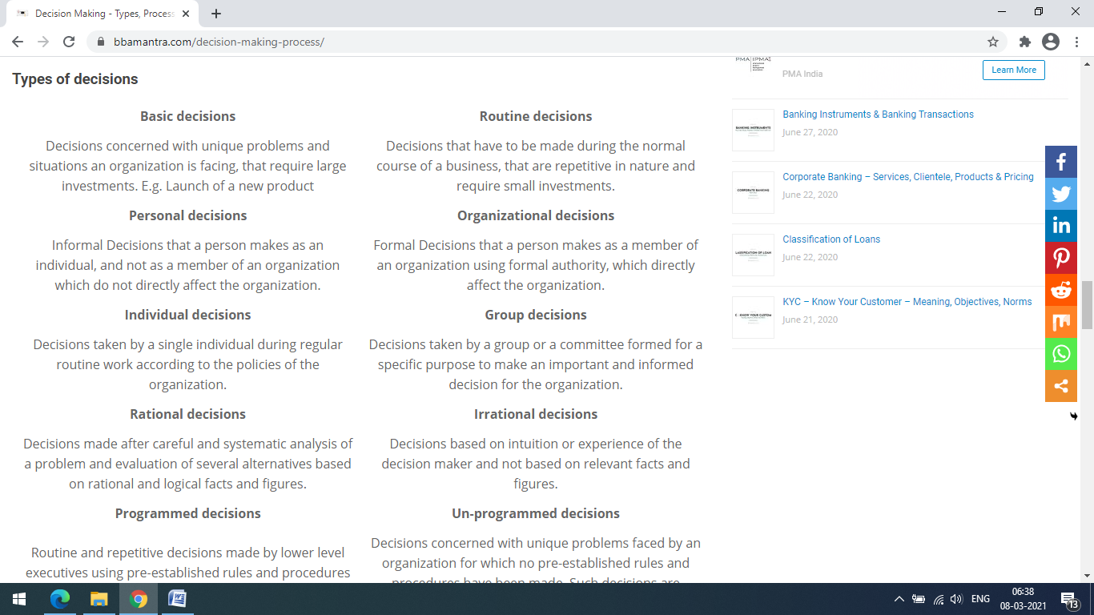

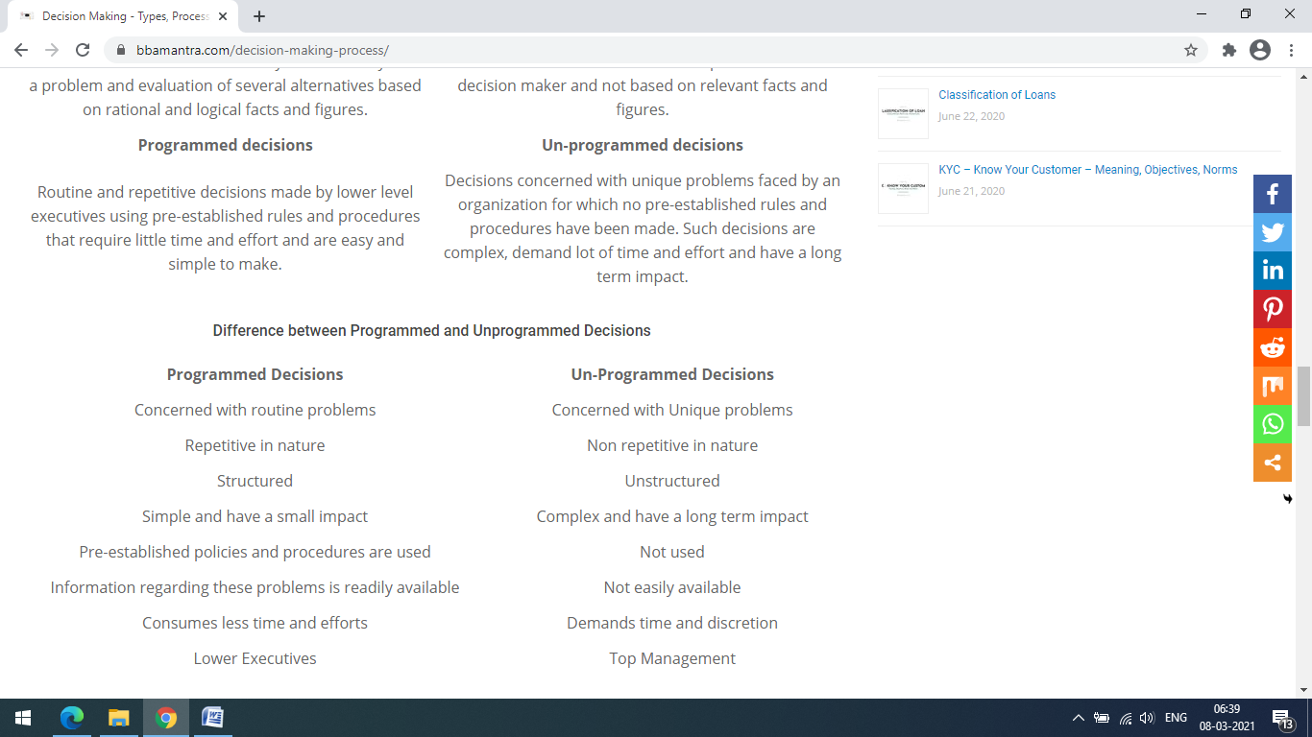

# TYPES OF DECISION MAKING

There are many ways of classifying decision in an organization but the following types of decisions are important ones :

**1. Tactical and Strategic Decisions**

Tactical decisions are those which a manager makes over and over again adhering to certain established rules, policies and procedures. **They are of repetitive nature and related to general functioning.** Authority for taking tactical decisions is usually delegated to lower levels in the organization.

Strategic decisions on the other hand are **relatively more difficult**. They **influence the future of the business** and involve the entire organization. Decisions pertaining to objective of the business, capital expenditure, plant layout, production etc., are examples of strategic decisions.

**2. Programmed and Non-programmed Decisions**

**Prof. Herbert Simon (June 15, 1916 - February 9, 2001),** an **American economist and psychologist,** has used computer terminology in classifying business decisions. These decisions are of a routine and repetitive nature. The programmed decisions are basically of a routine type for which systematic procedures have been devised so that the problem may not be treated as a unique case each time it crops up.

The non-programmed decisions are complex and deserve a specific treatment. **In the above example, if all the professors in a department stop their teaching work the problem cannot be solved by set procedural rules. It becomes a problem which requires a thorough study** of the causes of such a situation and after analyzing all factors a solution can be found through problem solving process.

**3. Basic and Routine Decisions**

**Prof. Katona has classified decisions as basic and routine**. Basic decision is those which require a good deal of **deliberation and are of crucial importance**. These decisions require the formulation of new norms through deliberate thought provoking process. **Examples of basic decisions are plant location, product diversification, selecting channels of distribution etc.**

Routine decisions are of repetitive nature and hence, require relatively little consideration. It may be seen that basic decisions generally relate to strategic aspects, while routine decisions are related to tactical aspects of a organization.

**4. Organizational and Personal Decisions**

Organizational decisions are those which **an executive takes in his official capacity** and which can be delegated to others. On the other hand, personal decisions are those which an **executive takes in his individual capacity** but not as a member of organization.

**5. Off-the-Cuff and Planned Decisions**

Off-the-cuff decisions involve **"shooting from the hip".(React without careful considerations of one’s words or actions)** These decisions can be taken easily and may be directed towards the purposes of the enterprise. On the other hand, planned decisions are **linked to the objectives of organization.** They are based on facts and involve the scientific process in problem solving.

**6. Policy and Operating Decisions**

Policy decisions are those which are taken by top management and which are of **a fundamental character affecting the entire business**. **Operating decisions are those which are taken by lower managemen**t for the purpose of executing policy decisions. Operating decisions relate mostly to the decision marker's own work and behaviour while policy decisions influence work or behaviour pattern of subordinates.

**7. Policy, Administrative and Executive Decisions**

**Ernest Dale (born in Hamburg, Germany and died at the age of 79) has classified decisions in business organization as under.**

(a) Policy decisions,

(b) Administrative decisions and

(c) Executive decisions.

**Policy decisions**are **taken by top management or administration of an organization.** They relate to major issues and policies such as the nature of the financial structure, marketing policies, outline of organization structure.

**Administrative decisions**are made by **middle management** and are less important than policy decisions. According to Ernest Dale the size of the advertising budget is a policy decision but selection of media would be an example of administrative decision.

**Executive decisions**are those which are made at the point where the **work is carried out.** Distinguishing between these three types of decisions **Dale writes,** "**Policy decisions set forth goals and general courses of action, administrative decisions determine the means to be used and executive decisions are those made on a day-to-day basis as particular cases come up".**

**Various Techniques of Decision Making**

* Group Discussions.
* Brainstorming.
* Delphi **technique**.
* Marginal Analysis.
* Cost-Benefit Analysis.
* Ratio Analysis.
* Financial Analysis.
* Break-even Analysis.